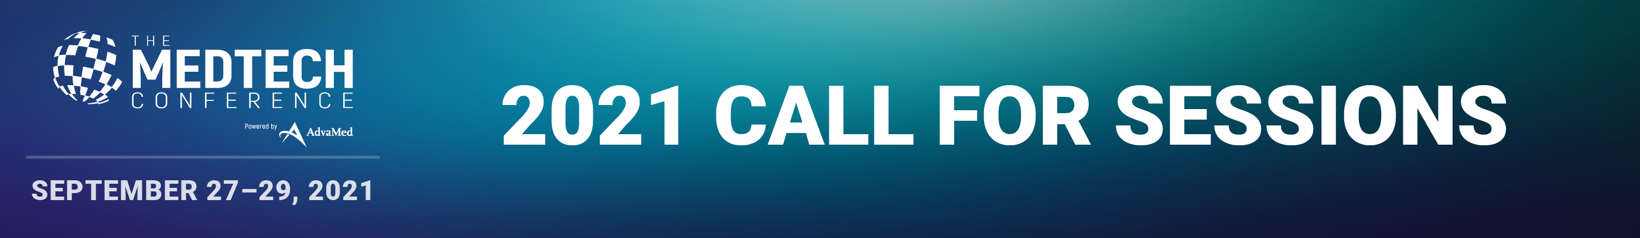
AdvaMed is seeking session proposals for The MedTech Conference that are relevant, timely and practical to the medical device, diagnostic and digital health industries. Organizing a session at The MedTech Conference allows you to set the agenda for the industry’s greatest minds and firmly establish your position as a leading authority in medtech.

Submission Guidelines
- No session proposal should feature more than one (1) individual from the same organization.
- Sessions are not designed to promote one company’s commercial interests.
- Speaker lineups must represent diverse perspectives with different companies, sectors, geographical locations, genders, etc.
- Do NOT invite your proposed speakers until you receive notification from AdvaMed that your session has been accepted.
- AdvaMed will issue all invitations to FDA and CMS speakers.
- AdvaMed is unable to provide honoraria or reimburse housing or travel expenses.

The deadline for session proposals is Friday, March 12, 2021 at 11:59 pm ET. Incomplete proposals will not be reviewed or considered.

Once your session proposal is submitted, you will not be able to make changes. Please use this worksheet to collaborate, edit and review with key stakeholders before submitting.

An advisory Program Committee and AdvaMed staff will review all complete, submitted proposals. Acceptance notifications will be sent via email in May 2021. Each proposal is graded according to the following criteria:

- Educational Content
  - Is The MedTech Conference the right forum for this session?
  - Will critical, timely and practical information be shared?
- Relevance & Timeliness
  - Will this be a hot topic in September 2021?
- Novel Topic
  - Does this session proposal offer new and important information?
- Speaker Expertise
  - Are these dynamic and expert speakers?
  - Are there one or more top, high quality speakers on session? CEOs, key thought leaders, policy makers and/or people of influence?
- Speaker Diversity
  - Are speakers from different geographic regions, sectors and companies?
  - Are speakers ethnically, culturally and gender diverse?
  - Do speakers represent multiple views?

If you have any questions, please contact program@advamed.org.

Session Title:
Kindly provide an informative and descriptive title for your proposed session. Please ensure that it is written exactly as you’d like to see it in print. 15 words max

Session Description:
250 words max

Why is the session proposal appealing to attendees at The MedTech Conference?
AdvaMed is particularly interested in receiving proposals that will appeal to global, senior level medtech executives. 100 words max.

Areas of Focus
Select the area of focus for which this session would be most appropriate. If applicable, choose a second option where this session could appear.
☐Business Strategies
☐ Digital Technologies
☐ Global Health
☐ In Vitro Diagnostics Tests & Technologies
☐ International
☐ Legal and Health Care Compliance Best Practices
☐ Patient Perspectives
☐ Payment & Health Care Delivery Issues
☐ Regulatory, Quality and Good Manufacturing Practices
☐ Other

Learning Objectives
Please provide three (3) learning objectives that are clear, measurable and achievable
1) Upon completion, attendees will be able to…
2) Upon completion, attendees will be able to…
3) Upon completion, attendees will be able to…

Additional Comments (optional):
How will this session be structured? What do you expect each speaker to cover and why are those perspectives important? Anything else to share with the Program Committee?

Session Organizer
Please provide full contact information for the person that will be serving as the session organizer. This person will receive all notifications and updates.
- Each organization may submit up to, and no more than, four (4) proposals.
- If selected, the session organizer will receive additional guidelines and a complete list of program deadlines.
- Upon confirmation of speakers, AdvaMed will communicate conference logistics directly with all speakers.

Name:
Job Title:
Company/Organization:
Email Address:
Country:
AdvaMed Member?: ☐ Yes ☐ No
The MedTech Conference Sponsor?: ☐ Yes ☐ No
Do you plan to attend The MedTech Conference in-person or virtually?
☐ I plan to attend in person and would like this session proposal considered for on-site programming opportunities.
☐ I'm unable to travel and would like this session proposal considered for virtual programming opportunities.
☐ Undecided

Proposed Speakers
Moderator
- Name:
- Job Title:
- Company/Organization:
- Biography:
- Email Address:
- Country:

Speakers
- Name:
- Job Title:
- Company/Organization:
- Biography:
- Email Address:
- Country:

